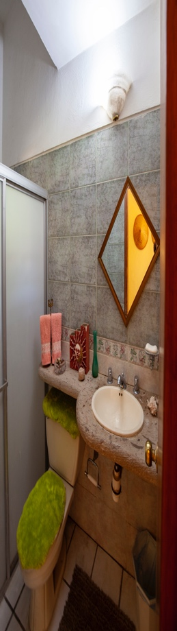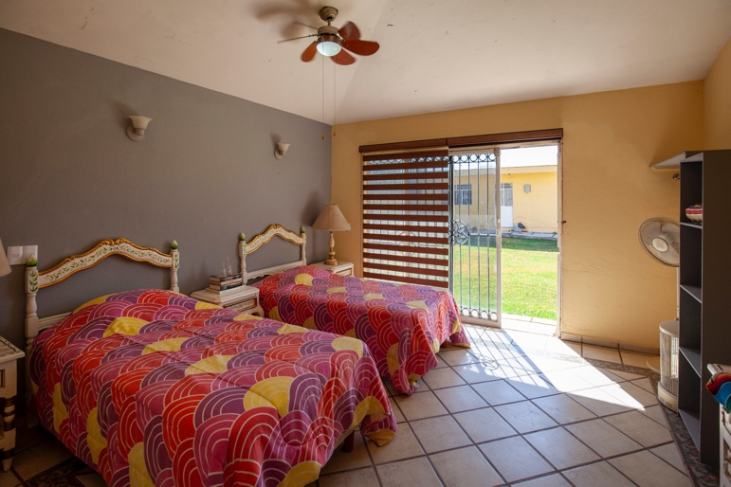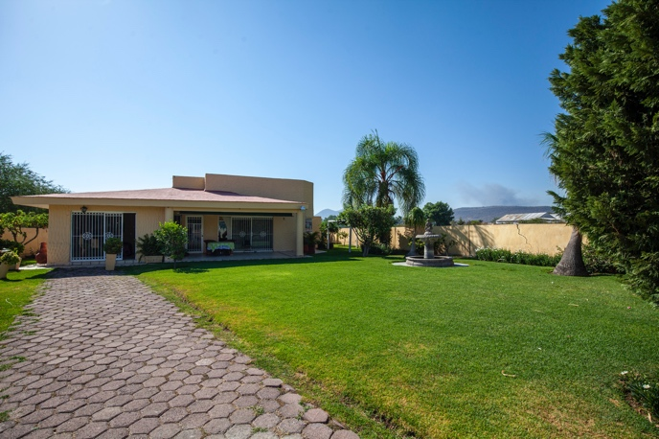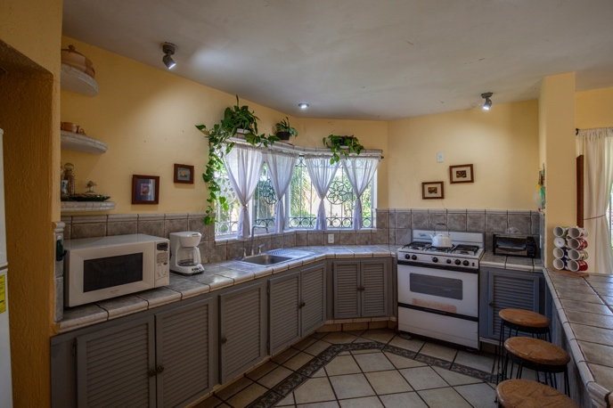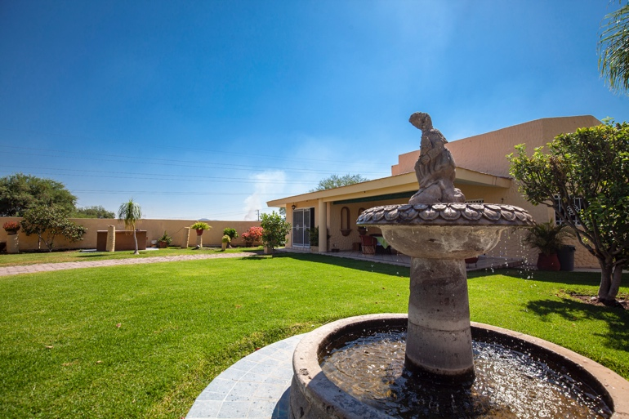

EL RODEO

Jalisco

Country

Setting

**Lot: 1000 square meters**

**Construction: approx. 209.65 square meters**

**Parking: off street**

**Main House. Casita**

**Bedrooms: 2. Rooms: 2**

**Bathrooms: 2. Bathrooms: 1**

**Laundry: in house**

**Living room: yes**

**Kitchen: yes**

**Dining room: yes**

**P: +52 33 2164 5301**

**www.bauerhouseproperties.com**

If a peaceful country retreat is what you are wanting, look no further. This quarter acre property on the outskirts of El Rodeo is fully fenced and is surrounded by well cared for farmland. As you enter through the main gate the tranquility and peace embrace you. The easy maintenance grounds are fully landscaped with a large variety of fruit trees and vines to enjoy all year long. The main house comes fully furnished and is flooded with natural light and a gas fireplace for the cool winter mornings. The floor plan was thoughtfully designed to ensure there is no unused space. As you walk towards the back section of the property there is enough room to build a large pool for the whole family to enjoy and a cozy two room casita equipped with a bathroom, giving you the extra space for your family get-aways. Just a 10 minute drive away you have all the conveniences such as grocery stores, restaurants and other amenities you may need. This country home is well priced so don’t wait to book your appointment. Quick possession is possible, allowing you to start creating great family memories.

**The COUNTRY HOUSE**

**Offered at: $2,300,000 Pesos**